**Computer Network**

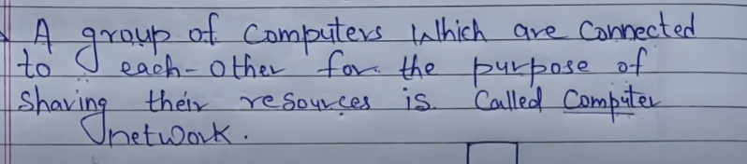

Fist CN - ARPANET - Advanced Research Projects Agency Network.

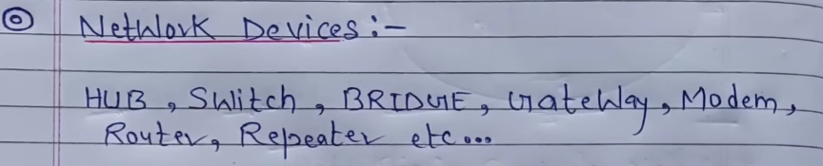

Network Types -

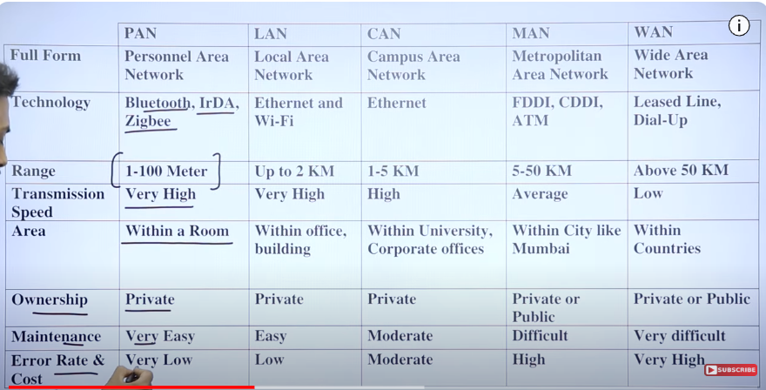

**IP Addressing** – Internet Protocol Addresses or Logical Addresses are 32 bits in length, Every Network connected to the internet has it’s own IP address.

IP4 =2^32, Range is 0-255, Separated by dot (1.2), Consists of 4 octets (each of 8bits), Has Numeric digits, Has 5 Classes.

IP6= 128 bits (3.4*10^38 or 2^128 or 340trillion), Range is 0-FFFF (65535), Separated by colon (1:2), Has Alpha Numeric Digits, Has No Classes.

32 bit is divided into 4 parts each of 8bits or octave.

Represented by

172.16.254.1 <= Dotted-Decimal Notations

10101100 00010000 11111110 00000010 <= Binary Notation

Properties of IP Add – Unique, Universal.

Classful Addressing – is the architecture.

Divided into 2 parts –

Prefix – defines the Network (NetworkID – Kis Network m jana hai)

Suffix – Defines the Node (HostID – kaun s computer m jana hai)

In classful Addressing, the address space is divided into 5 classes, A-E, Each part occupies some part of the space address.

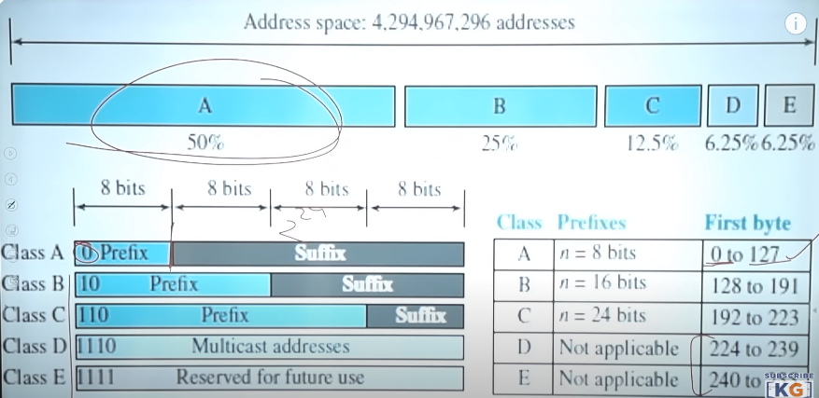

IP ki length total hai 32bits, binary me 2^32,

In **Class A**(50%) =NetID=8bits, HostID=24bits

Class A – First bit in first octate is 0, largest number that can be formed is 127(01…31times).

Toh first octate me agr 0 bit hai saamne yaa decimal me 127 m se koi bhi ek hai toh Class A hai.

____ ____ ____ ____

In First Octate,1st bit is 0 and is reserved, total combinations from rest 7 bits is 2^7=128

0 and 127 bit jo hote hai w reserved hote hai toh total range left is 1-126, So **total Numbers of Networks can be 126.**

0.0.0.0 Broadcasting Requirement.

127.0.0.1 for loopback address for software testing.

Toh 126 Networks ya City bna skta mai, Bache hue 4 octate hai HOSTID toh total number of computers aa skte is 2^24. Ab isme bhi just like networks First and Last Address ko bhi Reserve kr dete hai, 1st for Network’s Address, Last for Broadcasting.

When all HostID bits are 0 it is NetworkID, when they are 1 it represents Broadcast Address.

**Total Number of connections in Class A =2^32-1(is reserved)=2^31.**

**Number of Network is =2^7-2=126 (Even though 1bit i.e 0 substract kr chuke hum still 2 bits aur reserved hote isliye sirf Class A me 2 se subs krte.)**

**Number of Computers in each network = 2^24-2**

In **Class B**(25%) NetId=16bits, HostID=16bits

First two bits are 10

Range of first octate =128-191

Total Number of connections in Class B=2^32-2(10 are resreved)=2^30

16bits total 2bits reserved so size of Network =2^14 (isko substract mt krna 2 se coz Class A me reserved hote 2 addresses).

Total Computers in each network =2^16-2 (HostId me again 2 reserved hain)

In **Class C**(12.5%) NetID=24bits and HostId=8bits.

First three bits are 110,

Range =192-223

Total Number of connections in Class C=2^32-3(110 are reserved)=2^29

**Number of Network is =2^24-3=2^21**

**Number of Computers in each network = 2^8-2 (2are reserved in HostID)**

**Class D** (6.25) – First 4 bits are 1110=224-239 (Broad Casting krne k liye)

**Class E** (6.25) – First 4 buts are 1111=240-255 (Broad Casting krne k liye)

Total Number of connections in Class D and E = 2^32-4 =2^28.

**Subnetting** – Network ko Divide krne ko kehte hai.

1. Fixed

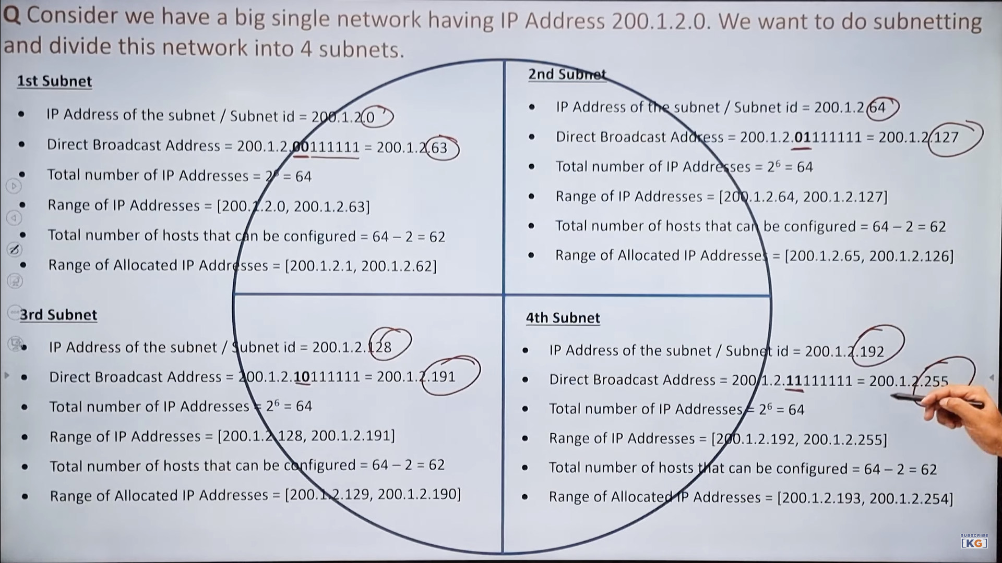

1. Variable -

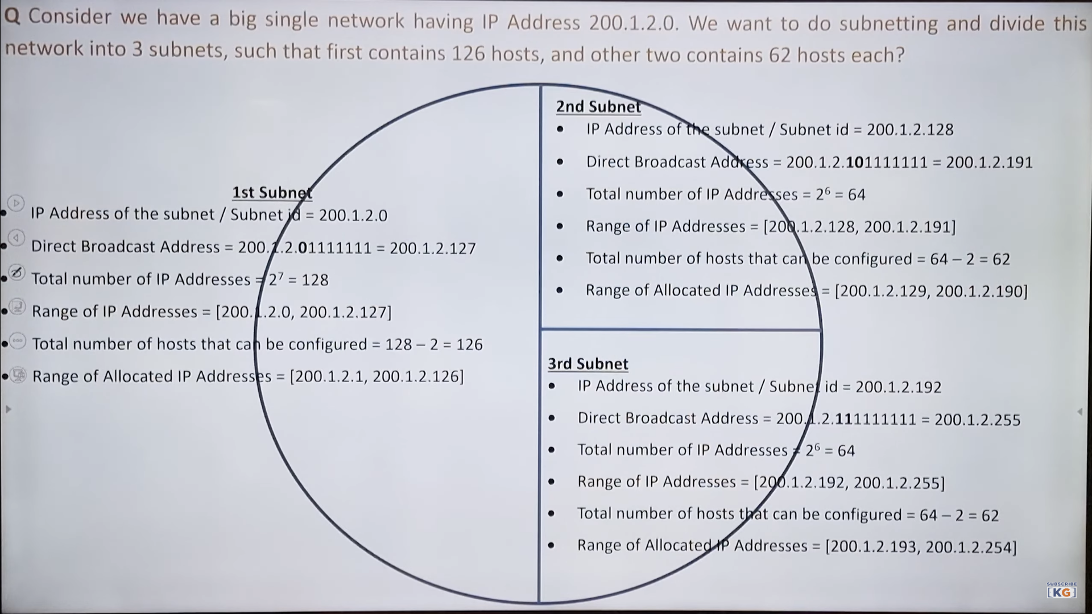

Jb subnetting kr diye toh batana hoga ki kis Class ka hai

Usk liye nitially jis class ka kaha gya tha utne toh uss class k hisaab s jitne bits NetID me rehte utne jagah p 11111…till the HostID starts. And

11111111=255

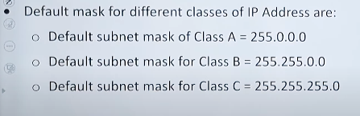

**OSI Model** – It is used to understand how data is transferred among different devices in a network. Open System Interconnection.

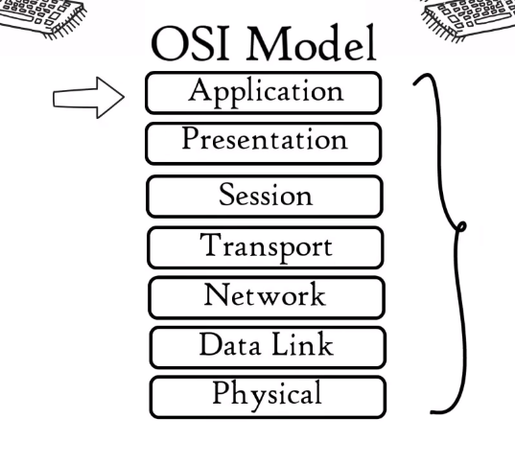**Each Layer is a packet of protocols.**

**1-3 - HW Layer**

**4th Heart of the OSI layers**

**5-7 – SW Layer**

**Application Layer –** Network applications like chrome use Application Layer Protocols it provides aa interface to interact with application. These protocols help in File transfer (FTP), Web surfing (HTTP/HTTPs), Email (SMTP), Virtual Terminals (Telnet).

**Presentation Layer –** It gets data from Application layer in the form of alpha numeric values and convert them into machine understandable Binary digits. This conversion is called **Translation**. This layer compresses the number of bits. This is called **Data compression** (Lossy or Lossless). Data Comp Reduces the size required to store the data. Data is **Encrypted** to maintain the integrity of the data (SSL or Secure Sockets Layer Protocol is used for Encryption or Decryption). (Data ko kis format m bheja jaye ki usko smjh aaye)

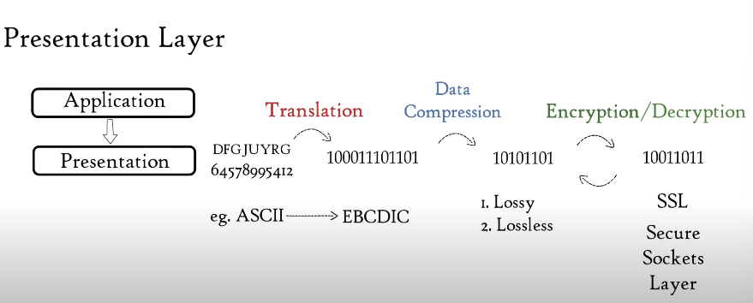

**Session Layer** – It helps in setting up and managing connections, and sending and receiving of data followed by termination of the connection. It uses API or

NETBIOS are example of an API which allows application in different devices to communicate with each other.

Session shuru hone se pehle Server Authentication krta hai with Name and Password ki sahi aadmi hai y ani, Firr Authorization krta hai ki aap koi particular file use kr skte hoy a ni. Session Layer dekhta hai ki user kaun sa file maang ra then bhejta hai usko in the form of data packets, toh it helps in Session Management.

**Transport layer –** It controls Reliability of Communication through flow control, Error Control and Segmentation.

Data Received from Session layer is divided into Data Units.

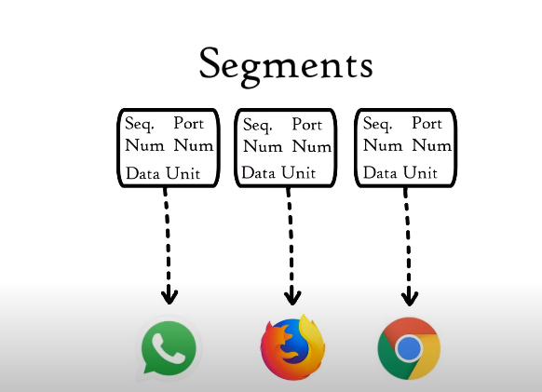

Port number helps to direct each segment to particular Application.

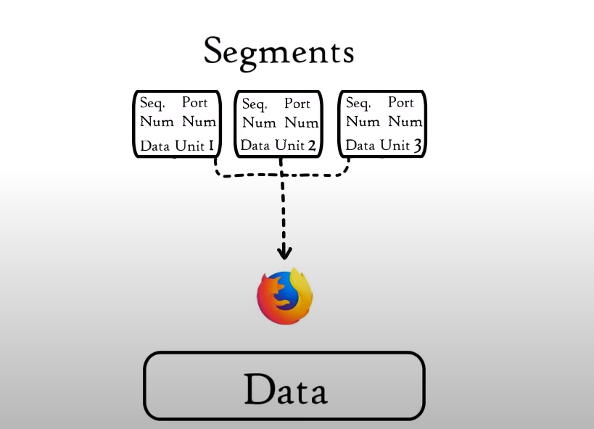 Sequence number helps to reassemble all the segments in correct order to form correct message at the receiver.

**Flow Control** helps the amount of data flow. 100Mbps aara hai aur phone 10mbps le skta toh transport layer kum krne bolega and vice-versa.

**Error Control** – It uses Automatic Repeat Request to retransmit the lost or corrupted data. Agr koi data aaya ni hai toh help krta thk krne m usko.

A group of bits called CheckSum is used to check for corrupted files.

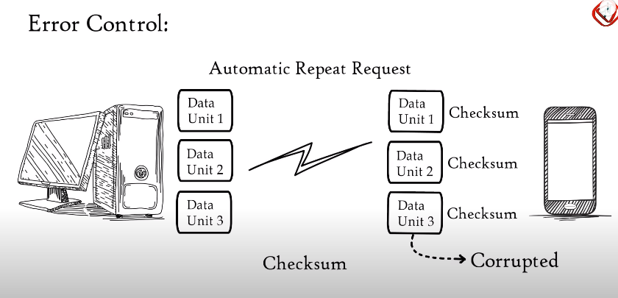

Protocols used are

**TCP**- Transmission Control Protocol it performs Connection-oriented Transmission and Used in Movie Streaming, TFTT, DNS

**UDP** – User Datagram Protocol. It performs Connectionless Transmission. Used in WWW, FTP

UDP is faster bcoz it does not provide feedback whether the Data was transferred or not.

**Network Layer** – It works for the transmission of received data segments from the Transport layer between Devices located a different Networks. Data units are called **Packets** and Routers reside in Network Layer.

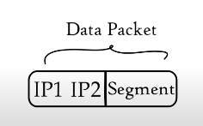

Services –

**Logical Addressing** – Every Network has its own IP address, Network layer assigns Sender and Receivers IP address to each segment to form and IP packet.

**Routing** – It is a method of moving data packets from source to destination. Uses IP address + Mask.

Ex FB dekna hai Network 2 k kisi Device ko toh wo IP address dekhega aur aisa apn padhe the about Subnet mask ki kaun sa Network ka kaun sa device hai batane ko toh Pehle server us respective Network m bjehega thn wahan s Device m jayega. (225.225.225.0 ka mtlb hai Class C type ka hai shuru k 3 octet batate hain Network aur last ka Device address.)

**Path Determination**

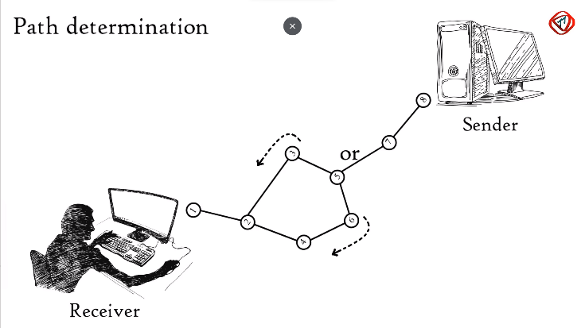 Uses Protocols like OSPF (Open Shortest Path First), BGP (Boarder Gateway Protocol) and IS-IS(Intermediate System to Intermediate System) to tell the best path for DATA DELIVERY.

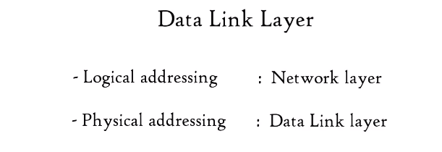

**Data Link Layer** –It receives Data Packets from Network Layer, Data Packets contain IP addresses of Sender and Receiver.

Physical Addressing is done in DLL where MAC address is assigned to Data Packet to form a frame.

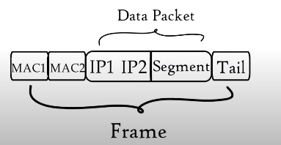MAC address is a 12digit or 6byte Alphanumeric Number embedded in

Network interface card of a computer.

Data unit in DLL is called Frame.

DLL is embedded as a software in Network interface card of a computer and provide means to transfer data via a Local media (Copper wire, Optical Fibre, Air).  
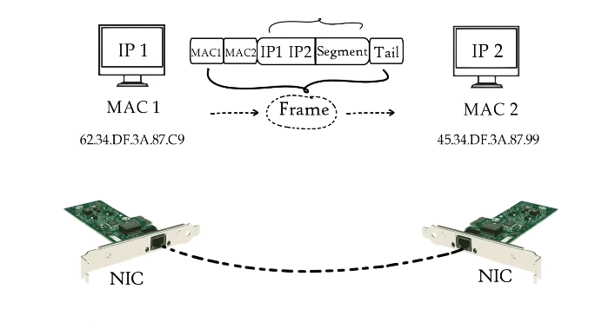

**DLL** allows upper layers of OSI model to access media using framing. It controls how a data is placed and received from the media using techniques such as Media Access Control and Error Detection.

**Physical Layer** – Converts the Binary sequence into signals and transmit over local media (electrical signal in case of Copper Wire, Light Signal in case of Optical Fibre and Radio Signal in case of AIR).

At the Receiving end Physical layer converts the Received signal into BITs and send it to DLL. At last Application layer protocols makes the msg visible in the Receivers computer screen.

**TCP/IP Model** – 2 Devices should follow some protocols to share data. TCP/IP are set of protocols.

TCP breaks the msgs into small data units called segments and send it to IP which deals with routing segments through the network to the destination. TCP at the destination combines the segments to form the msg.

TCP – Transmission Control Protocol

Alternate to TCP is UDP – User Datagram Protocol.

IP – Internet Protocol

**OSI** is used for Research Purpose, **TCP/IP** is a Practical Model.

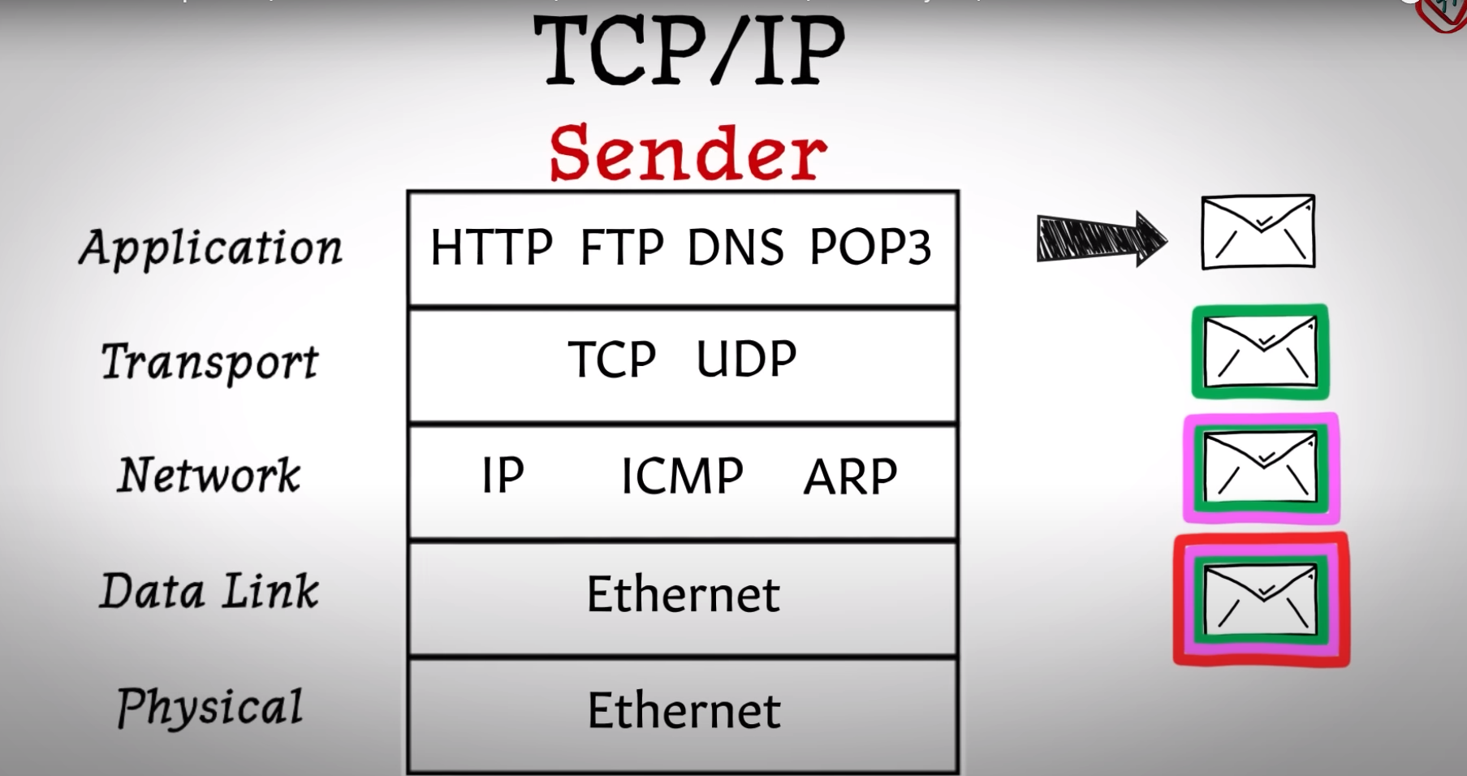

At every Layer the msg is encapsulated to it becomes larger at each layer.

Data unit at –

Application layer – Application msg

Transport layer – TCP Segment or UDP Datagram

Network Layer – IP Packet

Data Link Layer – Ethernet Frame.

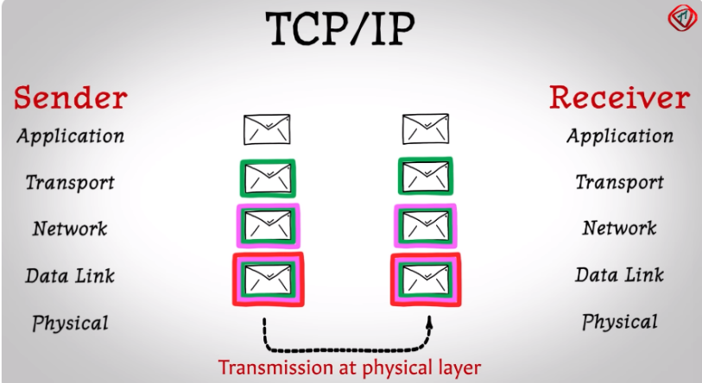At the other device as the data goes up the headers get removed.

**The Physical Later –** Conerts the Binary Digit into Signal and transmits it to the local Media.

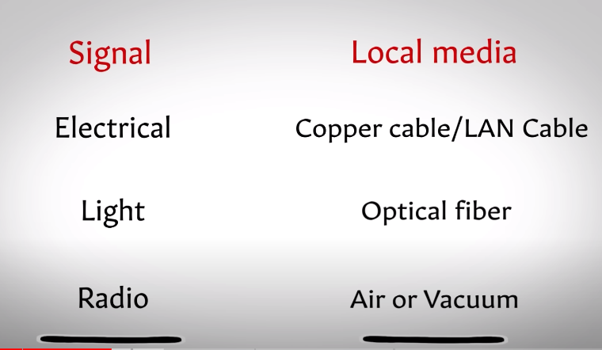 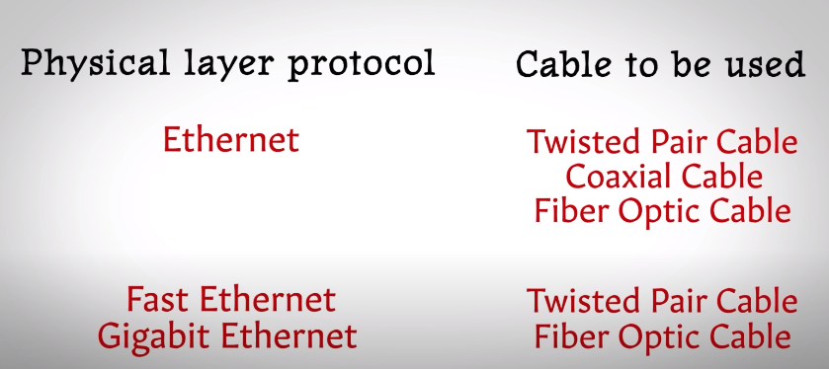

**The Data Link Layer –** It is Divided into 2 parts –

1. 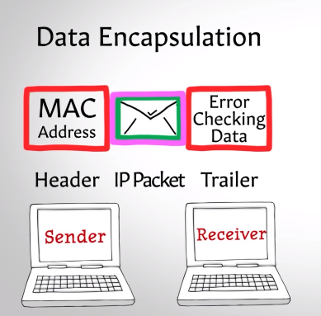**Medium Access Control (MAC) Sub Layer** –

**Data Encapsulation** - It Encapsulates the IP Packet with a Header and a Trailer. Header contains MAC Address and Trailer Contains Error Checking Data.

Mac Address is a 6byte embedded in NIC.

**Accessing Media** – It uses Carrier Sense Multiple Access(CSMA)/ Collision Detection(CD) – Agr 4 Computer ek hi Line se connected hai and data bhej re hai saath m to ek hi bhej payega baaki ko rykna padega warna collision hojayega. But collision ki wajah s delay bohot chota hota hai pt ani chlta.

1. **Logical Link Control (LLC)**
2. **Flow Control** – Restricts the amount of data (10mbps ki speed jhel skta ur udhr se 50mbps aara toh Dheere krne bolega system ko)
3. **Error Control** - Error Detection is done by using the Error Checking Data in the Trailer part. Frame Retransmission is done by ARQ(Automatic Repeat Request) so when a Sender sends something Receiver sends an Acknowledgement that the frame has been received if the ACK is not received then the Sender sends the Frame again. This is called ARQ
4. LLC Sublayer can also **Resize** the IP packet received from the network layer to fit them in the data link layer frames.

**Network Layer** – The transport layer send TCP Segment or UDP Datagram to NL. The NL adds IP Address and forms an IP Packet and uses Router to send the IP Packets to the routers.

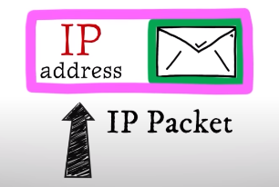

Services –

**Logical Addressing** – Every Network has its own IP address, Network layer assigns Sender and Receivers IP address to each segment to form and IP packet.

**Routing** – It is a method of moving data packets from source to destination. Uses IP address + Mask.

Ex FB dekna hai Network 2 k kisi Device ko toh wo IP address dekhega aur aisa apn padhe the about Subnet mask ki kaun sa Network ka kaun sa device hai batane ko toh Pehle server us respective Network m bjehega thn wahan s Device m jayega. (225.225.225.0 ka mtlb hai Class C type ka hai shuru k 3 octet batate hain Network aur last ka Device address.)

For Transfer of data in Same Network IP is not needed. The ARP Module take the Destination IP address from the IP address and returns the MAC address of the computer and converts it into an Ethernet Frame. Which is sent to the destination computer present in the same frame.

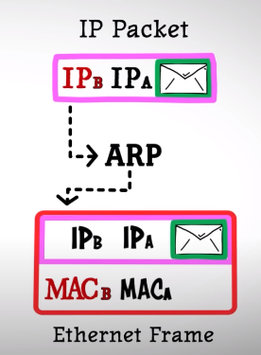

If the Computer is in a different network then ARP cant provide the Comp1 with Destination computer’s MAC Address so the intermediate Router’s MAC address is kept as the MAC address of the Destination Comp’s MAC Address.

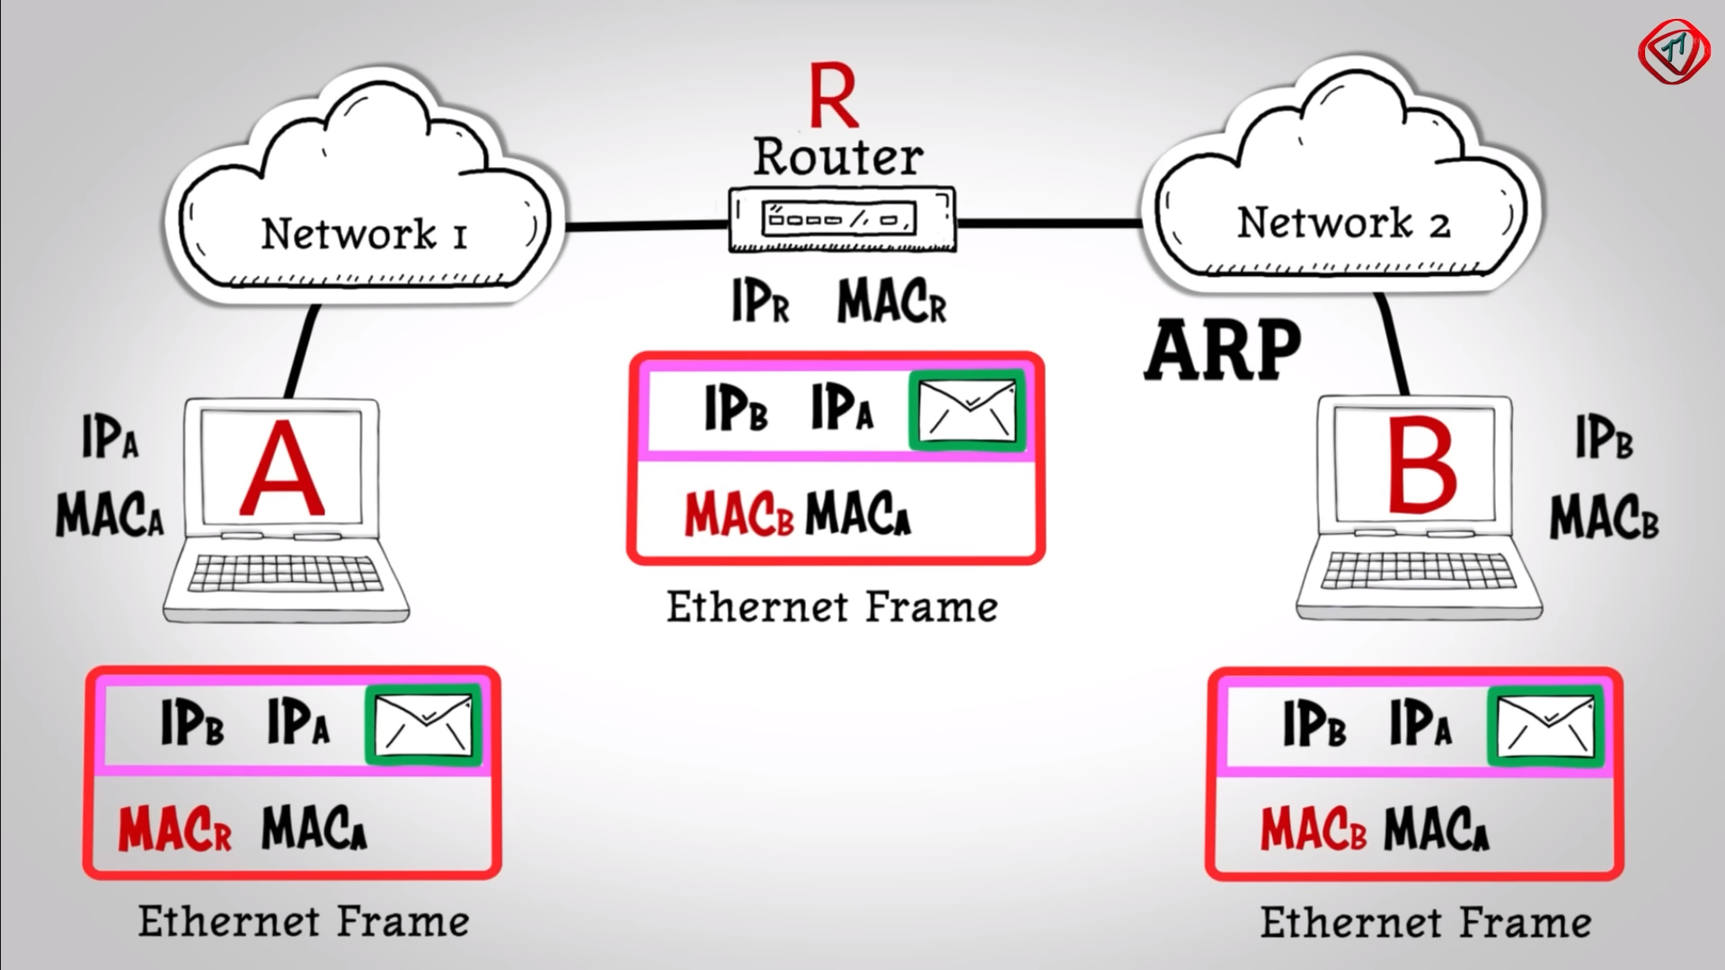

MACr hai router ka MAC Address toh Router tk jata hai data, Router dekhta hai ki Uska MACr address and Ethernet me Destination ka MACr Address same hai then wo forward krta hai aage and dekhta hai ki IP Address diff hai Router(IPr) ka and destination(IPr) ka tb wo ek ethernet frame wps banata hai MACb kr k with the help of ARP. Destination IPb kbhi chnge ni hota.

**Path Determination**

 Uses Protocols like OSPF (Open Shortest Path First), BGP (Boarder Gateway Protocol) and IS-IS(Intermediate System to Intermediate System) to tell the best path for DATA DELIVERY.

**Transport layer –** It controls Reliability of Communication through flow control, Error Control and Segmentation.

Data Received from Session layer is divided into Data Units.



Port number helps to direct each segment to particular Application.

 Sequence number helps to reassemble all the segments in correct order to form correct message at the receiver.

**Flow Control** helps the amount of data flow. 100Mbps aara hai aur phone 10mbps le skta toh transport layer kum krne bolega and vice-versa.

**Error Control** – It uses Automatic Repeat Request to retransmit the lost or corrupted data. Agr koi data aaya ni hai toh help krta thk krne m usko.

A group of bits called CheckSum is used to check for corrupted files.



Protocols used are

**TCP**- Transmission Control Protocol it performs Connection-oriented Transmission, TCP is reliable and Used in Movie Streaming, TFTT, DNS

Data Transmission via TCP has 3 phases – Connection Establishment, Data Transfer, Connection Termination

**Connection Establishment –**

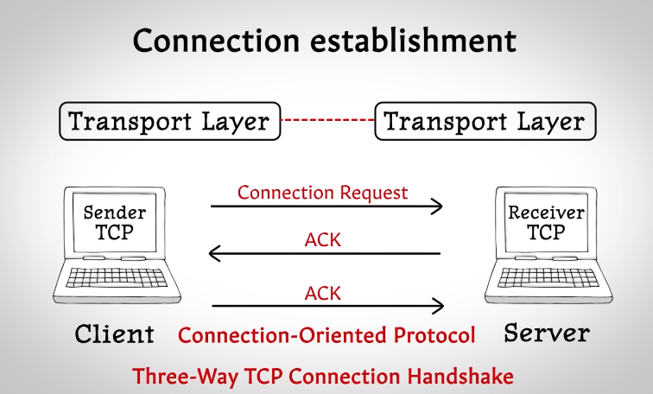

**Features in Data Transfer –**

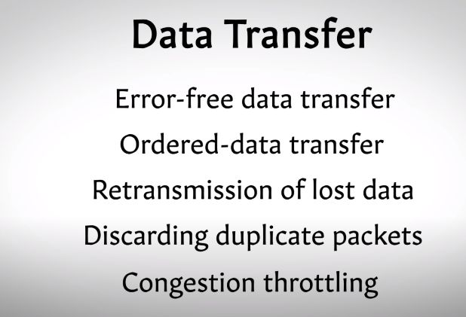

**Error free data transfer** is done by using a checksum - 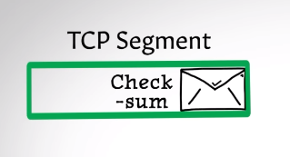,

The Sender inputs a value - 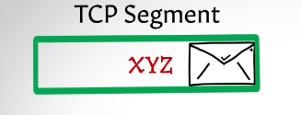

If the Receiver Enters the wrong Value - 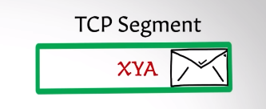

The TCP segment gets discarded.

As Ack is not transmitted again, The TCP segment is sent again and this time it matches.

**Ordered data transfer -**

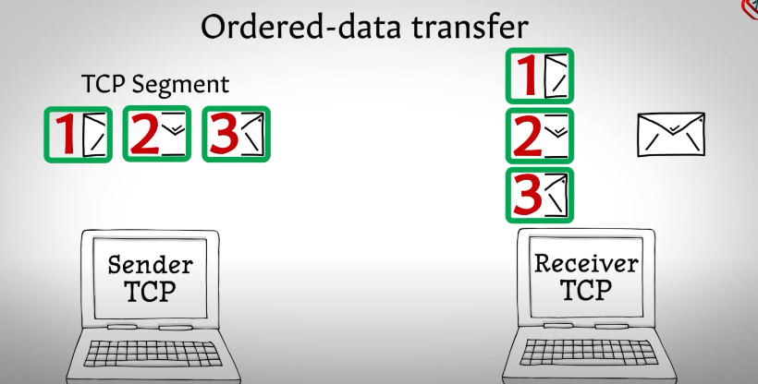

TCP adds a sequence number in the TCP segments and in the receiving end it is

The TCP module reconstruct the msg using the sequence.

**Retransmission of lost signals** – The receiver sends Ack for every TCP segment, if the ACK is not received to the sender it sends it again.

**Discarding Duplicate Packets** – if the same TCP segment that were thought to be lost by the sender is sent again thn the receiver with its unique Seq number discards it.

**Congestion throttling or flow control** – First TCP segment ko bhej k timer on krta hai and agar utne time m aagya ACK wps toh speed badha deta hai flow ka and agr kahin bhi delay aay toh retransmit krega. Aur agr zyada retransmit krna pd rah hai tb TCP speed slow kr deta hai.

**Connection termination -**

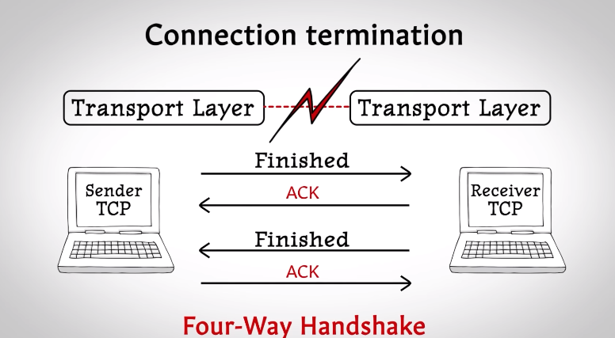Jb terminate krna hota hai tb TCP finished msg bhejta hain d dusra Device ACK bhejta hai and thn Receiver bhi Finished bhejta hai and Sender ACK bhjeta hai, toh, **Four Way Handshake** hota hai.

**UDP** – User Datagram Protocol. It performs Connectionless Transmission. Used in streaming videos, WWW, FTP, DNS, DHCP, SNMP, UDP lacks Error Checking and Correction

UDP is faster bcoz it does not provide feedback whether the Data was transferred or not.

**Application Layer** - Used by User application to transfer msg, It uses Application layer Protocol like Web browser use http/https for webs surfing.

Mail app =s like outlooks uses POP/SMTP for transferring Emails.

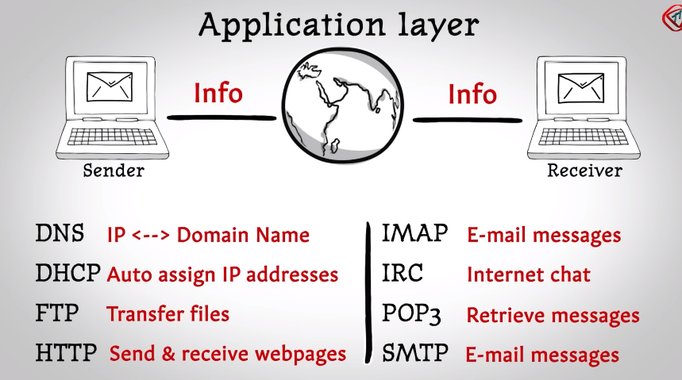

**DNS translates IP addresses to Domain name and vice-versa.**

**NIC –** if u want to access a website it needs to be converted into a format which can reach the server, it is carried out by NIC. NIC of an endpoint (Mobile, comp, Server) can convert the data into Electrical, Light or Radio Signal.

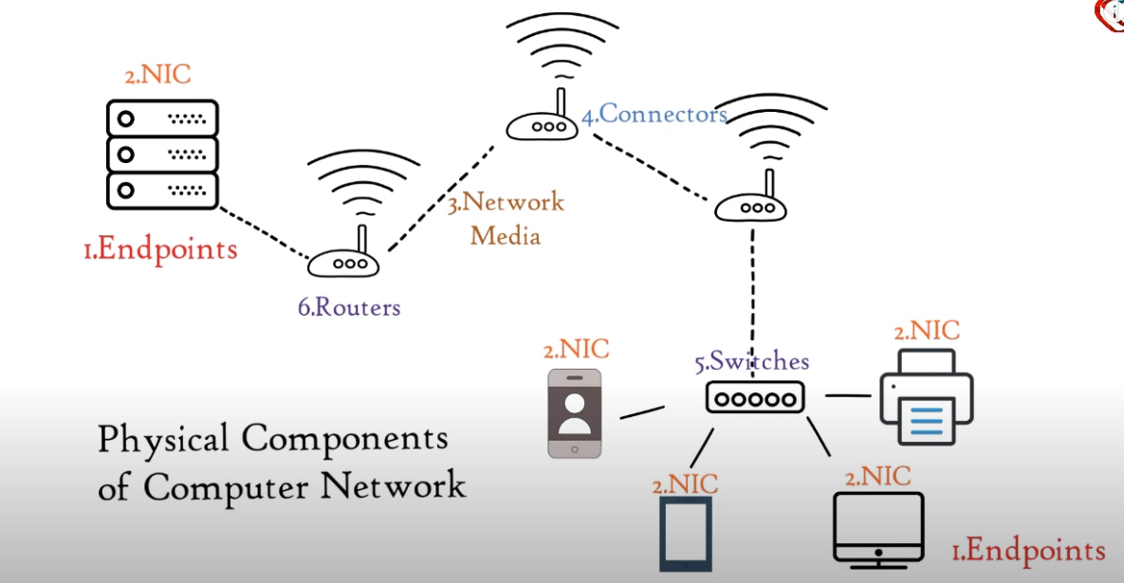

**DNS –** Domain Name System acts as a Translator, It maintains a system where Websites domain name (Google) are mapped to numbers (It’s IP address).

Servers that work together to provide IP address of the requested website to the webpage are called DNS Server.

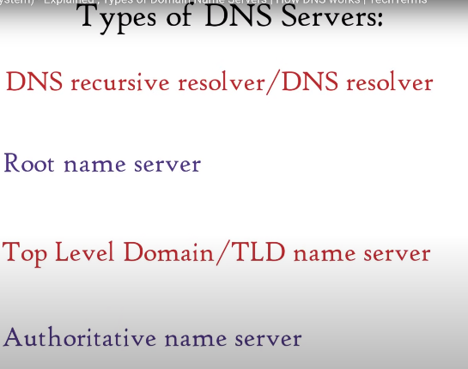DNS Resolver is provided by the ISP (Internet Service Provider like JIO).

It connects Web Browsers to DNS Name Servers.

Other Server Stores Info like -

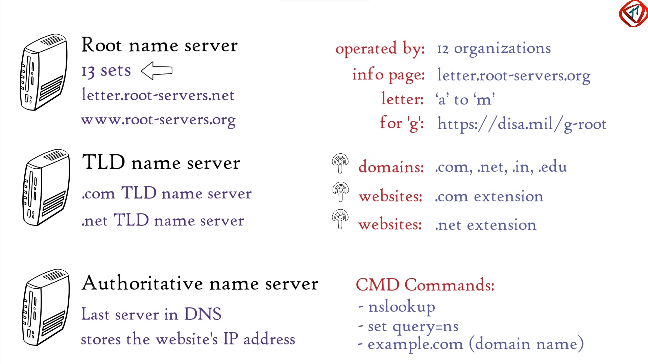

**RNS –** Kitne set hai? (harr set m bohot saare servers hai)

Likha kaise jata hai?

Details of harr root name server kahan mil skta?

Operate kitne log krte?

Infro Page harr RNS ka kidhr hai?

Letter kahan se kahan tk range krte?

G ko chodd k lekin (G ka home oage address hai.)

**TLD –** Domain names isk andar jo hai? .com server k andar .com extension wale aate same with .net.

**ANS –** last DNS server, Stores IP address of the requested website, ANS pta krna hai toh CMD commands se nikal skte like nslookup, set query=s

**How it works-**

1. If u search FB.com Web browser sends query to OS.
2. OS forward the query to DNS Resolver.
3. DNS Resolver checks if it has the IP address as Cache or not.
4. If not, then DNS query is sent to Root name server.
5. RNS checks the extension of the website (.com here).
6. Based on the extension RNS provide IP address of the TLD name Server to the DNS Resolver.
7. DNS Resolver then contacts TLD name Server and TLD name server provides IP address of Authoritative name server.
8. ANS provides the correct IP address of the website.
9. DNS Resolver saves it as a cache. DNS Sends the IP address to the OS.
10. OS sends it to web browser.
11. FB server loads it to the webpage.

**MAC Address-** Media Access Control also known as Physical or hardware address, It is a unique and permanent address for all electronic device.

It’s a 12digit,6bytes,48bits address.

mmm.mmm.sss.sss mm-mm-mm-ss-ss-ss mm:mm:mm:ss:ss:ss

**(m** represents m which is same for all the devices from tht particular company like HP, Dell and **s** is unique NIC number).

**DHCP Protocol** gives a unique IP address to each device, Gateway Router’s IP address, DNS Server’s IP address.

**ARP –** IP address hai dusre device lekin MAC address ka toh ARP use krte pta krne ko. ARP request Packet broadcast hota hai.

‘A’ Broadcast krega ye packet ko all over the network and jb wo particular Device apna IP address dekhega usm toh wo Reply krega tb ‘A’ ko mil jayega ‘B’ ka MAC address.

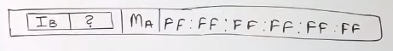 (Broadcast)

IB = IP address of B ? = MAC address MA = A(Sender) IP address.

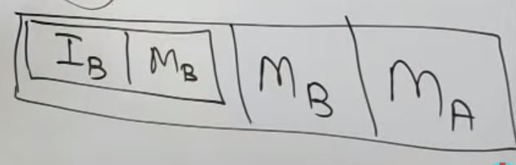MB = IP address of B (Unicast hoga ab)

Pehle Receiver ka MAC address hoga isliye broadcast k time MA hai lekin Unicast k time kyunki B send kr rah ai isliye MB pehle hai.

|  |  |  |
| --- | --- | --- |
| Hardware type  Ethernet =1 | | Protocol Type  IPV4 = (0800)16 or 0x0800 |
| Hardware length  Mac Address = 6 | Protocol Length  IPV4 = 4 | Operations  Request=1, Reply =3 |
| Sender’s Hardware Address =6Bytes | | |
| Sender’s Protocol Address =4Bytes IPA | | |
| Target Hardware Address =FF.FF.FF.FF.FF | | |
| Target Protocol Address =4Bytes IPB | | |

**Protocol –** It’s a set of rules which are used for digital Communication to connect network devices and exchange data.

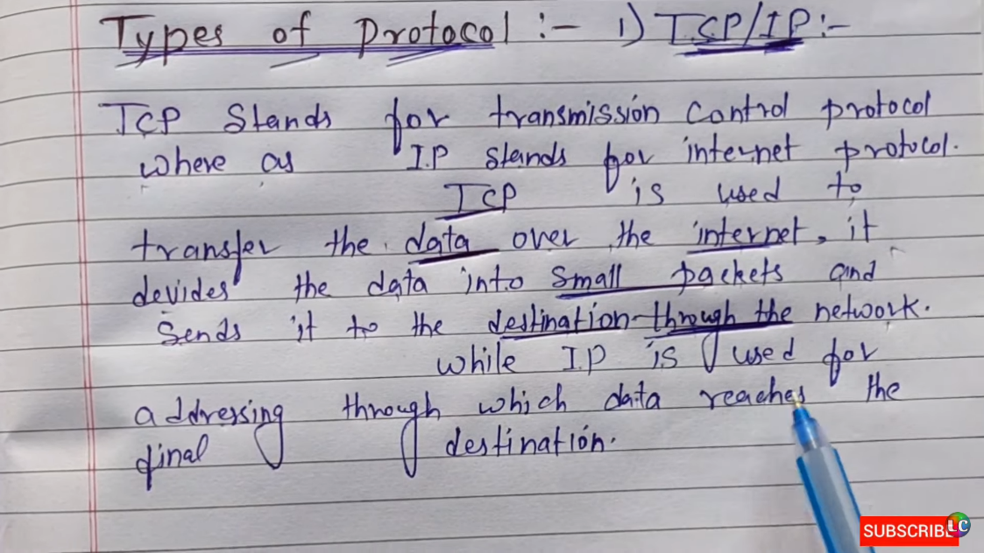TCP Establishes /Terminates the connection.

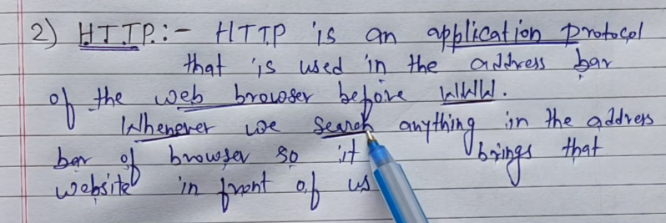

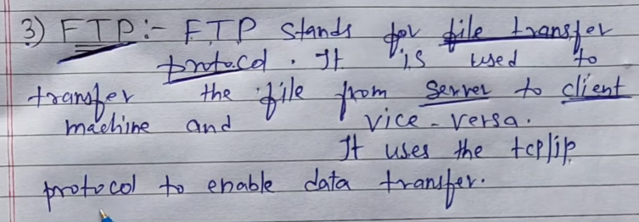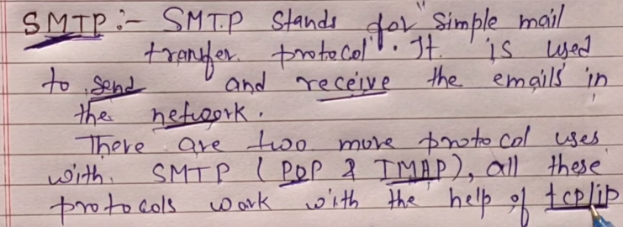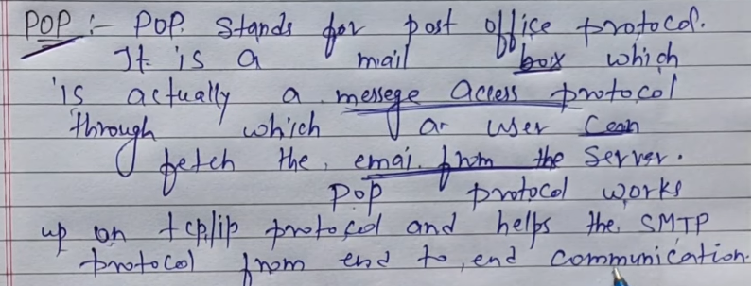

Receiver jo hai agr wo offline hai toh server k pass hai msg abhi. So, jb Receiver online aayega tb Bhej dega Server usko.

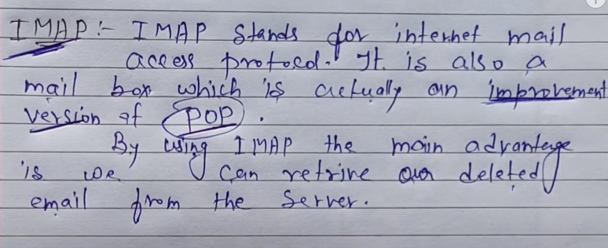

Receiver k pass jb aayag msg tb ek copy server k pass bhi hoti hai, aur agr galti se delet kr diya hai receiver ne toh wo server se download kr skta wps. Just Like **Mails hote hamare gmail me.**

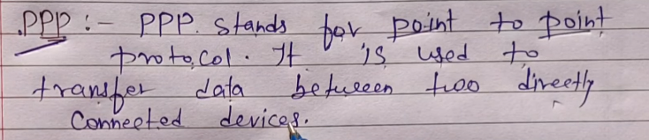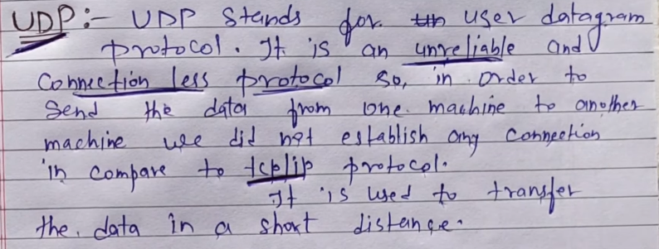

UDP use krta hai IP services use krta hai data transfer krne liye bina connection establish kiye.

**Protocol Port Number**

FTP 21

SMTP 25

PPP 110

IMAP 143

HTTP 80

HTTPS 443

**Telnet** – Teletype Network Protocol - Network protocol hai jo 2 devices ko virtually ya remotely connect krta hai. Based on the concept of NVT (Network Virtual Terminal). It is full duplex. It was overtook by Secure Shell Protocol (SSH) bcoz it was not secure.

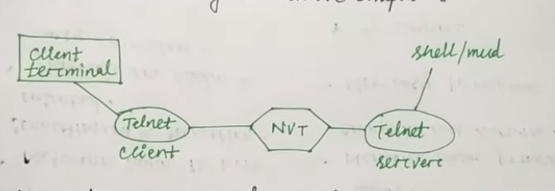

**ICMP** – **Internet Control Message Protocol** - ICMP is a network level protocol. ICMP messages communicate information about network connectivity issues back to the source of the compromised transmission. It sends control messages such as destination network unreachable, source route failed, and source quench. ICMP k discard hone ki probability by the router sbse zyada hota hai, Reason can be Due to congestion.

ICMP can be used for

1. **Error Handling** – Agr kisi wajah se packet ko discard kr diya gya hai by router toh wo sender tk ek ICMP packet send krta hai. Basically like a FEEDBACK.
2. **Request and Reply** - ICMP packet ko use kr k Sender- Reciver ko koi request bhejta hai and then Receiver reply kr skta hai with ICMP Packet.

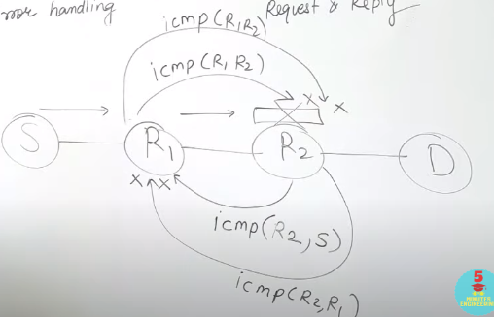Agr R2 ne discard kr diya koi packet sent by Sender toh wo ek ICMP packet bhejta hai, R1 ko transfer hota pehle ye tb R1 ICMP ko reject kr deta hai and Ek ICMP Packet bjeta hai R2 ko thn R2 firse discard kr deta hai and ek ICMP bhejta R1 ko, fir ye ek loop sa bnn jata.

Discard krne ka reason Congestion mtlb bohot saare requests ya traffic hoskta.

**Agr IP packet Discard hota hai toh ICMP packet generate kro lekin agr ICMP packet discard hota hai toh mt kro generate ICMP Packet kyunki Loop bnn skta hai.**

R2 ne kr toh diya Reject but kyun kiya aur kaun sa kiya wo pta krne k liye ek

**IP DATAGRAM** hota hai jo ki R2 send krega S ko.

IS= Destination IP, IR2 = Source IP, TYPE =Reason for discard,

8B | IS | ID = 8Byte Data and Header of the Packet that was discarded

|  |  |  |  |  |
| --- | --- | --- | --- | --- |
| √ | X | X | X | X |

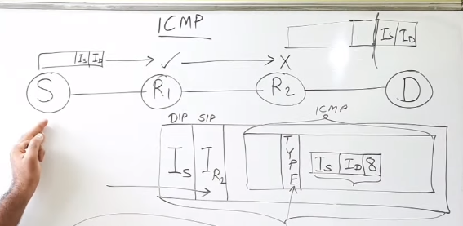Data Packets ka fragmentation hota hai toh uska agr 1st block discard hua toh hi ICMP Packet generate hoha.

**Cloud Computing –** is the delivery of on-demand computing services over the internet on a pay-as-you-go basis.

Types –

1. Deployment Model – Public Cloud(Bus), Hybrid Cloud(Car), Private Cloud(Taxi).

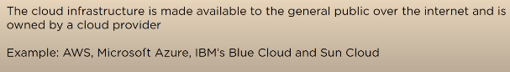

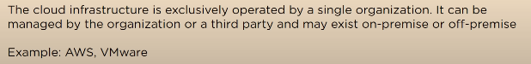

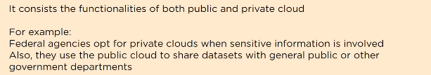

1. Service Model – Iaas, Paas, Saas.

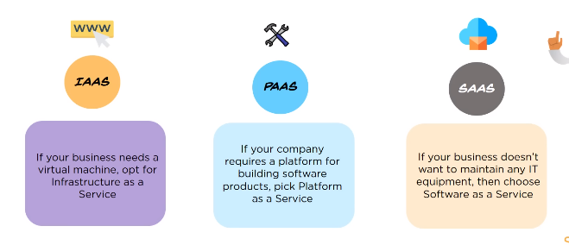

Used by IT Admins Software Dev End Customers

